Board of Advisors

Abbey, George W.S.
Albaugh, James F.
Aldrich, Arnold D.
Aldridge, Edward C.
Asker, Jim
Augustine, Norman R.
Bolden, Charles F.
Bowles, David E.
Brandenstein, Dan
Cabana, Robert D.
Callahan, Lisa
Campbell, Donald J.
Carr, Jeffrey E.
Carreau, Mark E.
Cazes, David
Chilton, Kevin P.
Coats, Michael L.
Collins, Eileen M.
Covey, Richard O.
Crippen, Robert
Culbertson, Frank L.
Dittemore, Ronald D.
Elachi, Charles
Elbon, John W.
Engle, Joe H.
Flynt, G. Allen
Free, James M.
Fuqua, Donald
Gerstenmaier, William H.
Griffin, Gerald D.
Griffin, Michael D.
Grunsfeld, John M.
Hartz, Jim
Heflin, J. Milt
Hendershot, Cynthia
Hernandez, Jorge
Hieb, Richard J.
Holloway, Tommy W.
Hutchinson, Neil B.
Hutchison, Kay Bailey
Johnson, Sandra G.
Karas, John C.
Kavandi, Janet L.
Kerwin, Joseph P.
Kranz, Eugene F.
Kropp, Debbie
Lunney, Glynn S.
Magnus, Sandra H.
May, Todd A.
McBride, David D.
McDonald, Vernon
Meyerson, Robert E.
Miller, Lon
Mitchell, Bob
Nield, George C.
O'Brien, Miles
Ochoa, Ellen
Parsons, William W.
Pavlovich, J. Gregory
Pickens, Thomas B.
Readdy, William F.
Reightler, Kenneth S.
Schmitt, Harrison H.
Scolese, Christopher J.
Shaw, Brewster H.
Sirangelo, Mark N.
Stafford, Thomas P.
Staples, William A.
Stegemoeller, Charles M.
Stephens, Richard D.
Suffredini, Michael
Swallow, Edward M.
Truly, Richard H.
Vantine, William
Wagner, Elizabeth
Whitesides, George
Young, John W.
For Immediate Release January 8, 2018
Media Contact: Lindsey Cousins
281-723-5683, lindsey@baysidegraphics.net

Mr. Robert Lightfoot, Acting NASA Administrator, to receive the 2018 National Space Trophy

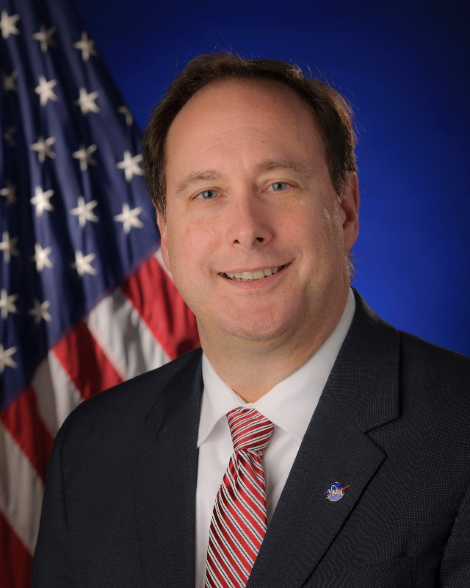
Mr. Robert Lightfoot
(NASA photo)

Bay Area, Houston, Texas (January 8, 2018). The Rotary National Award for Space Achievement (RNASA) Foundation has selected Mr. Robert Lightfoot, NASA Acting Administrator, to receive the 2018 National Space Trophy. The banquet honoring Mr. Lightfoot will be held on April 27, 2018, at the Houston Hyatt Regency in Houston, Texas.

Rodolfo Gonzalez, President of the RNASA Foundation said, "We are excited about the Board of Advisors pick for the 2018 National Space Trophy and the Foundation looks forward to recognizing Mr. Lightfoot as the guest of honor at the RNASA Space Award Gala.”

Mr. Lightfoot was nominated for the award by Dr. Ellen Ochoa, Johnson Space Center Director, Mr. Robert Cabana, Kennedy Space Center Director and Mr. Todd May, Marshall Space Flight Center Director. The nominators selected Lightfoot for his, “continued extraordinary accomplishments towards achieving NASA's vision and mission, sustaining America's leadership in space, and pushing the frontiers of science, discovery, and exploration.

Lightfoot said, "I am truly humbled and honored to receive the prestigious RNASA National Space Trophy. I feel very fortunate to be part of NASA and consider this honor a reflection of the incredible achievements and mission successes of our NASA team."

Mr. Lightfoot earned a bachelor’s degree in mechanical engineering from the University of Alabama in 1986. His career with NASA began in 1989 at the Marshall Space Flight Center where he started as a test engineer and program manager. In 1999 he joined the Stennis Space Center in Mississippi where he was later named Propulsion Test Director in 2002.

In 2003, following Columbia accident, Lightfoot’s proven track record led him to Washington, DC where he was named Assistant Associate Administrator for the Space Shuttle Program. In this role, he led the return to flight efforts. It was in 2004 that President Bush unveiled a new Vision for Space Exploration. The new direction called for the retirement of the Space Shuttle Program, development of a new exploration vehicle and the completion of the ISS. Mr. Lightfoot led the charge as the first Shuttle Transition Manager.

Lightfoot transitioned back to Marshall in 2005 as Manager of the Space Shuttle Propulsion Office where he oversaw the manufacture, readiness, and launch of the space shuttle propulsion elements for four space shuttle missions. In 2007 he transitioned, first as Deputy Director and in 2009 to MSFC Center Director, where he managed a $2.6 billion budget, over 30,000 civil service and contractors and nearly 7 million square feet of facilities including the Michoud Assembly Facility in New Orleans. Michoud is one of the world’s largest manufacturing sites and is the critical assembly center for NASA’s exploration vehicles.

In 2012, Mr. Lightfoot accepted the position as NASA’s Associate Administrator, the agency’s highest ranking civil servant position, responsible for the day to day operations of the Agency’s aeronautics, science, technology, and human spaceflight efforts.

Mr. Lightfoot became NASA’s Acting Administrator in January of 2017 and is now the longest serving Acting Administrator in NASA’s history. He has gained significant White House engagement for the importance of a strong space program. This has included an ISS downlink in the Oval Office with the President, visits to three NASA Centers by the Vice President, including JSC for the new Astronaut Candidate Class announcement, and the signing of the NASA Transition Authorization Act of 2017. Passed unanimously by Congress, the act authorizes the development of a long-range plan for deep space human exploration, endorses NASA’s efforts to nurture a commercial market and guarantees improved health care for astronauts. 2018 marks NASA’s 60th anniversary.

Looking toward the future, Lightfoot remarks “working with commercial partners, NASA will fly astronauts from American soil to the ISS on the first new crew transportation systems in a generation in the next couple of years. We are continuing the development of solar electric propulsion for use on future human and robotic missions. NASA is building a sustainable human spaceflight program to take humans to the Moon and beyond. We continue to make great progress toward these and many other major milestones as part of the diverse portfolio of work we execute as we explore, discover, and develop on behalf of the American people.”

The RNASA Foundation invites members of the public and the aerospace community to attend the black-tie event on April 27, 2018, at the Houston Hyatt Regency, where Mr. Lightfoot will be recognized with the National Space Trophy. This year will be RNASA’s 32nd annual National Space Trophy Banquet. Please visit http://www.rnasa.org/tables.html to reserve your table for the RNASA Banquet and find information about sponsorships and tickets. To reserve a room at the Houston Hyatt Regency, please visit http://www.rnasa.org/houston.html or call 713-654-1234 and request the RNASA group rate.

About RNASA: The Rotary National Award for Space Achievement (RNASA) Foundation was founded by the Space Center Rotary Club of Houston, Texas, in 1985 to organize and coordinate an annual event to recognize outstanding achievements in space and create greater public awareness of the benefits of space exploration. The nonprofit Foundation presents the National Space Trophy and Stellar Awards each year. The RNASA website is http://www.rnasa.org/.

