Board of Advisors

Abbey, George W.S.
Albaugh, James F.
Aldrich, Arnold D.
Aldridge, Edward C.
Augustine, Norman R.
Bolden, Charles F.
Bowles, David E.
Brandenstein, Dan
Cabana, Robert D.
Callahan, Lisa
Campbell, Donald J.
Carr, Jeffrey E.
Carreau, Mark E.
Cazes, David
Chilton, Kevin P.
Coats, Michael L.
Collins, Eileen M.
Covey, Richard O.
Crippen, Robert
Culbertson, Frank L.
Dittemore, Ronald D.
Elachi, Charles
Elbon, John W.
Engle, Joe H.
Flynt, G. Allen
Free, James M.
Fuqua, Donald
Gerstenmaier, William H.
Geyer, Mark
Griffin, Gerald D.
Griffin, Michael D.
Grunsfeld, John M.
Hartz, Jim
Heflin, J. Milt
Hendershot, Cynthia
Hernandez, Jorge
Hieb, Richard J.
Holloway, Tommy W.
Hutchinson, Neil B.
Hutchison, Kay Bailey
Johnson, Sandra G.
Karas, John C.
Kavandi, Janet L.
Kerwin, Joseph P.
Kranz, Eugene F.
Kropp, Debbie
Lightfoot, Robert
Lunney, Glynn S.
Magnus, Sandra H.
May, Todd A.
McBride, David D.
McDonald, Vernon
Meyerson, Robert E.
Miller, Lon
Mitchell, Bob
Mulqueen, Mark E.
Nield, George C.
O'Brien, Miles
Ochoa, Ellen
Parsons, William W.
Pavlovich, J. Gregory
Pickens, Thomas B.
Readdy, William F.
Reightler, Kenneth S.
Schmitt, Harrison H.
Scolese, Christopher J.
Shaw, Brewster H.
Sirangelo, Mark N.
Stafford, Thomas P.
Staples, William A.
Stegemoeller, Charles M.
Stephens, Richard D.
Suffredini, Michael
Swallow, Edward M.
Truly, Richard H.
Vantine, William
Wagner, Elizabeth
Whitesides, George
For Immediate Release March 18, 2019
Media Contact: Lindsey Cousins
281-723-5683, lindsey@baysidegraphics.net

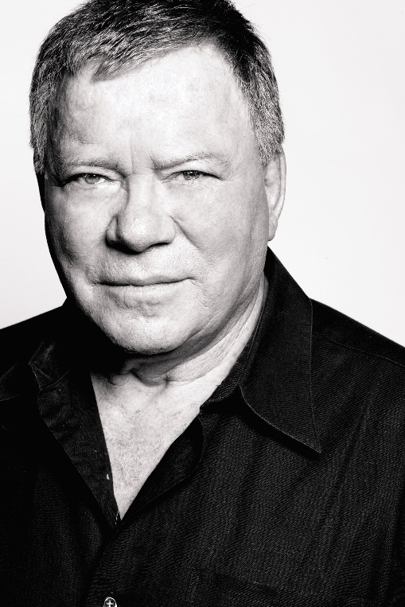

William Shatner to attend 2019 RNASA Banquet as an honored guest

Bay Area, Houston, Texas (March 18, 2019). The Rotary National Award for Space Achievement (RNASA) Foundation is pleased to announce that William Shatner, best known for his role as Captain James Kirk of Star Trek’s USS Enterprise, will speak at this year’s black tie space awards gala on April 26.

The RNASA Foundation was founded by the Space Center Rotary Club of Houston, Texas, in 1985 to organize and coordinate an annual event to recognize outstanding achievements in space and create greater public awareness of the benefits of space exploration. The nonprofit Foundation presents the National Space Trophy and Stellar Awards each year. This year’s NST will be presented to Mr. David Thompson, retired President and CEO of Orbital ATK.

Shatner has long been an advocate of international space exploration efforts. In recent years, he has supported numerous NASA outreach activities to educate the public and to inspire a new generation of explorers, leading to his selection for the RNASA Space Communicator Award in 2018.

In 2011, Shatner donated his time in honor of Space Shuttle Discovery’s final flight. He recreated the famous Star Trek introduction for the crew of STS-133 saying, “These have been the voyages of the space shuttle Discovery. Her 30-year mission: to seek out new science, to build new outposts, to bring nations together in the final frontier, to boldly go and do what no spacecraft has done before.” He also narrated the space shuttle 30th anniversary documentary.

In 2012, Shatner narrated the Grand Entrance to Mars presentation which guided viewers through Curiosity’s complex landing on the Martian surface. In order to make a successful soft landing, the Curiosity spacecraft had seven minutes to slow down from 13,000 mph as it rocketed through the atmosphere. It was appropriately dubbed the “seven minutes of terror”.

He continued his support in the fall of 2017 by sending a message to the Voyager spacecraft on its 40th anniversary. It read “We offer friendship across the stars. You are not alone.” Launched in 1977, the Voyager probe is beaming back data from the furthest reaches of our solar system. As of January 2018, Voyager was 13 billion miles from Earth.

The RNASA Foundation invites members of the public and the aerospace community to attend the black-tie event on April 26, 2019, at the Houston Hyatt Regency. This year will be RNASA’s 33rd annual Space Awards Gala.

Please visit http://www.rnasa.org/tables.html to reserve your table for the RNASA Space Awards Gala and find information about sponsorships and tickets. To reserve a room at the Houston Hyatt Regency, please visit http://www.rnasa.org/houston.html or call 713-654-1234 and request the RNASA group rate.

